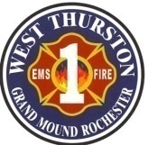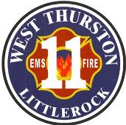
Thurston County Fire Protection Districts 1 & 11
West Thurston Regional Fire Authority
“Serving Better Together”
10828 Littlerock Rd SW
Olympia WA 98512
360.352.1614

Board of Fire Commissioners General Meeting

Monday, July 22, 2024, at 1730 hr.

In-Person: 18720 Sargent Rd SW, Rochester St. 1-1
Zoom virtual meeting link:
https://us02web.zoom.us/j/86399434512?pwd=di9qSHIzVk5OSjByM1lPY3UyM2RQQT09
Meeting ID: 863 9943 4512
Passcode: 148054

Call to Order

Attendance:

Additions/Deletions to Agenda:

- Public Comments/Presentations

- Labor Management

- New Business (Action Items)

ITEM | Page(s) | RESPONSIBLE | OUTCOME
- Resolution 2024-005 M & O Levy  - Prothman  - Staffing |  | Shannon  Shannon  AC Drake | Approve/Reject  Approve/Reject  Approve/Reject

Unfinished Business (ACTION ITEMS)
ITEM | Page(s) | RESPONSIBLE | OUTCOME

Unfinished Business (NONACTION ITEMS)
ITEM | Page(s) | RESPONSIBLE | OUTCOME
- Communications (NONACTION ITEMS)
ITEM | Page(s) | RESPONSIBLE | OUTCOME

- Department Reports
ITEM | Page(s) | RESPONSIBLE | OUTCOME
Recruit & Retention Coordinator |  | Andrea Reynoldson | Informational

- Good of the Order:

- Adjournment:

