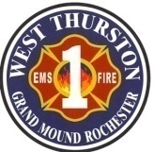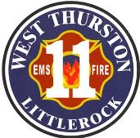
Thurston County Fire Protection Districts 1 & 11
West Thurston Regional Fire Authority
“Serving Better Together”
10828 Littlerock Rd SW
Olympia WA 98512
360.352.1614

Board of Fire Commissioners Workshop

Monday, November 25, 2024, at 1730 hr.

In-Person: 10828 Littlerock Rd SW, Olympia St. 1-2
Zoom virtual meeting link:
https://us02web.zoom.us/j/7583465513?pwd=MHdFQkR2Z3hPME1Dbm5Mekt5bkZMdz09&omn=87215941167
Meeting ID: 758 346 5513
Passcode: 54321

Call to Order

Attendance:

Additions/Deletions to Agenda:

- Public Comments/Presentations

- Labor Management

- New Business (Action Items)

ITEM | Page(s) | RESPONSIBLE | OUTCOME
- 2025 Budget  - M & O Levy  - Board Responsibility & Conduct | 1-21 | Shannon  Shannon  Shannon | Accept/Reject

Unfinished Business (ACTION ITEMS)
ITEM | Page(s) | RESPONSIBLE | OUTCOME

Unfinished Business (NONACTION ITEMS)
ITEM | Page(s) | RESPONSIBLE | OUTCOME
- Communications (NONACTION ITEMS)
ITEM | Page(s) | RESPONSIBLE | OUTCOME

- Department Reports
ITEM | Page(s) | RESPONSIBLE | OUTCOME

- Good of the Order:

- Adjournment:

